**Tourism**

**Introduction**

Tourism is the generic term used to cover both demand and supply that has been adopted in a variety of forms and used throughout the world. Tourism essentially refers to the activities undertaken by visitors, also known as the visitor economy. The tourism industry encompasses all activity that takes place within the visitor economy. Tourism is the movement of the tourists from one place to another place. It is the temporary short-term movement of people to destinations outside the place where they normally live & work includes the activities they indulge in at the destination as well as all facilities and services specially created to meet their needs. Tourism does not only mean traveling to a particular destination but also includes all activities undertaken during the stay. It includes day visits & excursions. The movement can be in your country or the tourists can also travel to the foreign destinations for the tourism purpose.

The overwhelming success of international and domestic tourism has given rise to a pressing demand for quality professional acumen. Requirements for skilled and efficient human capital poses a serious threat to the future competitiveness of this service industry.

**Adventure tourism**

As a kind of tourism in India, adventure tourism has recently grown in India. This involves exploration of remote areas and exotic locales and engaging in various activities. For adventure tourism in India, tourists prefer to go for trekking to places like Ladakh, Sikkim, and Himalaya. Himachal Pradesh and Jammu and Kashmir are popular for the skiing facilities they offer. Whitewater rafting is also catching on in India and tourists flock to places such as Uttranchal, Assam, and Arunachal Pradesh for this adrenalin- packed activity. Various kinds of adventure on water, land, and air can be enjoyed in India. The various kinds of adventure tourism in India are: Rock climbing, Skiing, Camel safari, Para gliding, Mountaineering, Rafting in white water, Trekking. As a kind of adventure tourism in India, rock climbing is relatively new. Due to the presence of climbing rocks in large numbers throughout the country, rock climbing as a kind of adventure tourism in India is taking off in a big way. The various places in India where tourists can go for rock climbing are Badami, Kanheri Caves, Manori Rocks, and Kabbal. Skiing in India as a kind of adventure tourism has become popular in the last decade. The country has a large number of hill stations which have excellent skiing facilities. This has given rise to skiing adventure tourism in India. The places in India where tourists can go for skiing are Manali, Shimla, Nainital, and Mussoorie. Whitewater rafting in India is a relative newcomer in the domain of adventure tourism in India. This has been increasing due to the presence of a number of rivers, water falls, and rapids. The places where a tourist can go for whitewater rafting in India are Ganga, Alaknanda, and Bhagirathi rivers. Trekking as a part of adventure tourism India has grown recently. Many tourists are coming to India in order to go trekking in the various rugged mountains present in India. Camel safari in India has also become very popular due to the initiatives taken by the tourist boards of some Indian states. The most famous destinations in India for camel safaris are Bikaner, Jodhpur, and Jaisalmer. Paragliding in India has developed recently and paragliding facilities are available in a lot of places in India. Mountaineering in India is also quite popular in the arena of adventure tourism. Tourists can go to Garhwal, Himachal Pradesh, and Jammu and Kashmir for indulging in mountaineering. Adventure tourism India has registered a formidable growth in recent years. For this growth to continue, efforts must be taken by the government of India so that India ranks alongside international destinations for adventure tourism.

**Wildlife tourism**

India has a rich forest cover which has some beautiful and exotic species of wildlife some of which that are even endangered and very rare. This has boosted wildlife tourism in India. The places where a foreign tourist can go for wildlife tourism in India are the Sariska Wildlife Sanctuary, Keoladeo Ghana National Park, and Corbett National Park. Medical tourism. Tourists from all over the world have been thronging India to avail themselves of cost- effective but superior quality healthcare in terms of surgical procedures and general medical attention. There are several medical institutes in the country that cater to foreign patients and impart top-quality healthcare at a fraction of what it would have cost in developed nations such as USA and UK. It is expected that medical tourism in India will hold a value around US$ 2 billion by 2012. The city of Chennai attracts around 45% of medical tourists from foreign countries.

**Pilgrimage tourism**

India is famous for its temples and that is the reason that among the different kinds of tourism in India, pilgrimage tourism is increasing most rapidly. The various places for tourists to visit in India for pilgrimage are Vaishno Devi, Golden temple, Char Dham, and Mathura Vrindavan.

**Eco tourism**

Ecotourism India has developed recently, for the concept itself is a relatively new one. Ecotourism entails traveling to places that are renowned for their natural beauty and social culture, while making sure not to damage the ecological balance. Ecotourism pertains to a conscious and responsible effort to preserve the diversity of a naturally endowed region and sustaining its beauty and local culture. Indians have been known since ages to worship and conserve nature. So the growth of ecotourism in India is but natural. Also, the government of India has set up the Ministry of Tourism and Culture to promote ecotourism in India alongside other types of tourism.

**Cultural tourism**

India is known for its rich cultural heritage and an element of mysticism, which is why tourists come to India to experience it for themselves. The various fairs and festivals that tourists can visit in India are the Pushkar fair, Taj Mahotsav, and Suraj Kund mela. Cultural tourism India is the predominant factor behind India s meteoric rise in the tourism segment in recent years, because from time immemorial, India has been considered the land of ancient history, heritage, and culture. The government of India has set up the Ministry of Tourism and Culture to boost cultural tourism in India. The ministry in recent years has launched the Incredible India! campaign and this has led to the growth of culture tourism in India. India has had many rulers over the centuries and all of them made an impact on India's culture. One can see the influence of various cultures in dance, music, festivities, architecture, traditional customs, food, and languages. It is due to the influence of all these various cultures that the heritage and culture of India is exhaustive and vibrant. This richness in culture goes a long way in projecting India as the ultimate cultural tourism destination given boost to tourism in culture in India. The most popular states in India for cultural tourism are: Rajasthan, Tamil Nadu, Uttar Pradesh, Uttaranchal. Tamil Nadu is also famous for cultural tourism in India, for it shows the Dravidian tradition and culture. It has many temples which mirror the rich cultural heritage of India. Uttar Pradesh has a lot of tourist places which also testify to the rich culture of the country. The most famous monument is the Taj Mahal in Agra. Cities like Varanasi, Allahabad, Vrindavan, and Ayodhya in Uttar Pradesh also attract a large number of tourists for they encapsulate beautiful vignettes of India. Uttaranchal is also famous for cultural tourism India. This state has the Himalaya mountains which are called the abode of the Gods. Many ancient temples are found in the Kumaon and Garhwal regions of the state.

**Wellness tourism**

Wellness tourism is one of the fastest growing forms of international and domestic tourism. This form of tourism involves people who travel to a different place to pursue activities that maintain or enhance their personal health and wellness, and who are seeking unique, authentic or location-based experiences. Wellness tourism include massages, body treatments, facial treatments, exercise facilities & programs, weight loss programs, nutrition programs, pre- and post-operative Spa treatments and mind/body programs.

**Business Tourism**

Business tourism can be defined as travel for the purpose of business . Business Tourism can be divided into three sections: Trading for goods to be resold on a wholesale basis Conduct business transactions e.g. visiting a client, contract negotiations Attending a conference, exhibition or event associated with their business.

**Heritage tourism**

India Heritage tourism India has registered an immense growth in the last few years, ever since additional initiatives were taken by the government of India to boost India s image as a destination for heritage tourism. India has always been famous for its rich heritage and ancient culture. So the onset of heritage tourism in India was long anticipated. India s glorious past and cultural diversity make a potent blend which attracts millions of tourists each year to its heritage tourist attractions. The government of India and the Ministry of Tourism and Culture encourage heritage tourism in India by offering several benefits to the Indian states that are particularly famous for attracting tourists. India's rich heritage is amply reflected in the various temples, palaces, monuments, and forts that can be found everywhere in the country. This has led to the increase in India's heritage tourism. The most popular heritage tourism destinations in India are: Taj Mahal in Agra, Mandawa castle in Rajasthan, Mahabalipuram in Tamil Nadu, Madurai in Tamil Nadu, Lucknow in Uttar Pradesh, Delhi, the Indian capital. The maximum number of tourists who come to India visit the Taj Mahal for it is one of the 7 wonders of the world. It is made of marble which has intricate inlay work done in an exquisite and meticulous style. The Mandawa castle in Rajasthan, built in 1775 reflects India's rich heritage and attracts thousands of tourists each year to Rajasthan which seems especially popular for its antique paintings, jade jewelry, palaces, and costumes. Mahabalipuram has sculptural and architectural sites which are considered the greatest in India. Mahabalipuram has cave temples that have been carved from granite blocks and belong to the 7th century. This is the primary reason why many heritage tourists in India visit this place. The tourism of heritage in India has also increased due to the interest of many foreigners in the temples of India. Madurai is known as the temple city due to the presence of a large number of temples in the city. And for this reason, many tourists go and visit the place each year. The most important temple in Madurai is the Meenakshi temple. Heritage tourism India has grown in recent years but there is scope for further development which can be attained only through combined efforts of the government of India and the tourism boards.

**Leisure Tourism**

They usually visit hill stations, beaches, waterfalls, zoological parks, etc.

**Cruise Tourism**

Rail and road transport are very common among the people. Some tourists, go in for Air / Cruise mode of transport even if it is costlier. At any cost, the tourists desire to enjoy the holiday even before they reach the actual tourist spot.

**Sports Tourism**

People now from the rich and the poor, the young and the old spare leisure time for sports activities. One segment of them undertakes tours to nearby cities and abroad for sports activities. Inevitably Tourism participates in their tour.

**Educational Tourism**

Students undertake trips to abroad to secure higher studies and professionals to polish their talents. Tourism here automatically gets triggered. The types of tourism in India have grown and this has boosted the Indian economy. That it continues to grow efforts must be taken by the Indian government, so that the tourism sector can contribute more substantially to the nation s GDP.

**Abstract**

Tourism became a common topic while the level of tourist requirements increased dramatically. Generally traditional travel websites provided general information or price list of hotels, transport tickets, etc. These kinds of information cannot satisfy travellers any more. A challenge for travel websites is to present creative and special travel plans to users. In order to achieve this target, relying on software reuse and abstraction techniques, this paper demonstrates a new system, aiming to generate creative travel plans. This system can be divided into three part (Information Abstraction, Information Reuse, Information Formulation). Firstly, the system is to derive the characteristic query into different travel components with a high level of abstraction. Secondly, the system is to reuse different elements from different travel components to comprise a creative travel plan. Finally, the system builds a creativity metrics system to rank the redived plans based on the level of creativity.

The speed of development of tourism in our country is very fast. Some cities have achieved very good results in the development of tourism, which has led to the development of the local economy. In accordance with its own reality, a city strives to create a distinctly distinctive tourism economic model that effectively serves the people. Against this backdrop, this article has conducted in-depth analysis and research on the development of tourism in the city, and put forward the idea of designing a smart tourism management system based on cloud services for the city. Specifically, the following research contents have been developed. According to the functional requirements, the functional modules of the system can be divided and designed in detail. According to performance requirements and functional requirements, the overall architecture, logical architecture, and physical architecture of the system can be designed in detail. In the application system, business information is stored in the database, and the conceptual structure design and logical structure design of the database are also the main content of this chapter. A detailed description of each part of the detailed design process will be given below.

Ongoing developments in information technology (IT), particularly with respect to the Internet, have led to changes in the way tourism-related information is distributed. These changes have affected the planning and consumption patterns of tourists before and during their trips. Since the majority of tourists retrieve information from multiple information sources on the web, it is essential to define the differences in these sources and identify the distinct characteristics or properties of each source in order to understand the needs and tendencies of tourists. This study classifies online tourism information sources into four types: blogs, public websites, company websites, and social media websites. Five website attributes are identified: accessibility, security, information–trust, interaction, and personalization.

Information technologies (ITs) prevail in all functions of strategic and operational management. As information is the lifeblood of tourism, ITs provide both opportunities and challenges for the industry. Despite the uncertainty experienced in the development of ITs in tourism, the ‘only constant will be change’. Increasingly, organizations and destinations, which need to compete will be forced to compute. Unless the current tourism industry improves its competitiveness, by utilizing the emerging ITs and innovative management methods, there is a danger for exogenous players to enter the marketplace, jeopardizing the position of the existing ones. Only creative and innovative suppliers will be able to survive the competition in the new millennium. This paper provides a framework for the utilization of technology in tourism by adopting a strategic perspective. A continuous business process re-engineering is proposed in order to ensure that a wide range of prerequisites such as vision, rational organization, commitment and training are in place, so they can enable destinations and principals to capitalize on the unprecedented opportunities emerging through ITs.

**Keywords**

Tourism, Internet, types of tourism, travels management, online booking, recommendations, advertising, packages

**Benefits**

* Faster processing time and more accurate data for travel requests and reimbursements
* Travel recommendations
* Reducing the space between traveller and travel agencies
* Users can know about the place
* Users get recommendations on the basis of the season
* Users can contact advertisers
* Increase the visibility of places
* Employment at the destinations
* Promoting tourism

**Issues**

 During the phase-out period for paper travel documents, recommendations or at the time of ticket bookings, users will have questions and will need effective support.

**Primary clients**

Travellers, travel agencies, foreigners, researchers who wants to know about different places, environmentalists, any student or teacher who wants to know about certain place.

**Risks**

 The clients and the visitors must become familiar with the new online portals and login processes. Effective communication, design of the portal and training will be needed to the freshers who are operating the computers newly.

**MEASURES OF UNIQUENESS**

Our portal is very unique compared to other websites because in this we cover all the tourist’s hub. Most of the other websites only select famous or limited tourist places.

In our portal, we have a privilege to add any number places, and their descriptions. The travel agencies can advertise their packages in our website as well.

**Technologies Used**

**Python-django:**

Django is the best framework for web applications, as it allows developers to use modules for faster development. As a developer, you can make use of these modules to create apps, websites from an existing source. It speeds up the development process greatly, as you do not have to code everything from scratch.

**HTML:**

 HTML defines the structure and layout of a Web document by using a variety of tags and attributes. HTML code **ensures the proper formatting of text and images** so that your Internet browser may display them as they are intended to look.

**CSS:**

We are able to keep every visual aspect of the website completely separated from the content, using CSS when designing our websites allows us to quickly create layouts, and troubleshoot any problems. We know that regardless of the page, we control all elements from one (or several) stylesheet.

**SQLITE(database) :**

**SQLite** is cross-platform database management system. It can be used on a broad range of platforms like Windows, Mac OS, Linux, and Unix. It can also be used on a lot of embedded operating systems like Symbian, and Windows CE. **SQLite** offers an efficient way of storing data, the length of the columns is variable and is not fixed.

**Objectives**  
This application is developed to provide best travelling services to the customers and travel agents. We have developed tours and travel management system to provide a search platform where a tourist can find their tour places according to their choices. This system also helps to promote responsible and interesting tourism so that people can enjoy their holidays at their favourable places. This system also helps to develop tourism with different cultures so that they enrich the tourism experience and build pride. We develop this system to create and promote forms of tourism that provide healthy interaction opportunities for tourists and locals and increase better understanding of different cultures, customs, lifestyles, traditional knowledge and believes. This system also provides a better way to connect with various events.  
  
This system also gives tours related information like which places are tourist attractions, cities, and provinces. Tourist can also get the Map and navigation system and temperature and weather information. Tourist can also book tours through our tours and travels management system. This system also keeps a history of visited places of its users.

### **Modules of travel and tour management system**

**User Management**  
  
a. Login.  
  
b. User profile.  
  
c. Update information.  
  
d. Role based rights.

**Data Flow Diagrams**

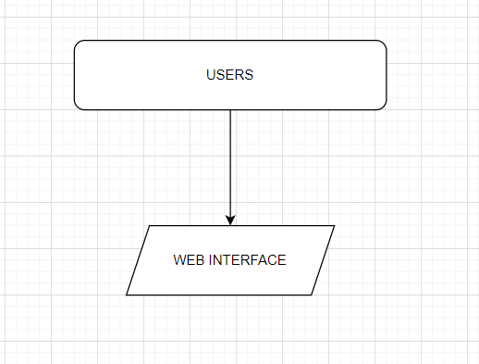

**Users interact directly with the web interface**

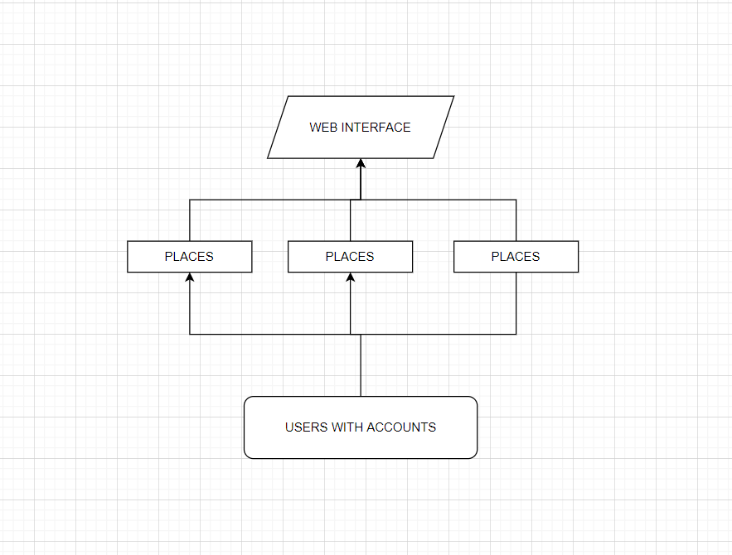

**Users with accounts can upload and update the places and description. The description is reflected into the web interface.**

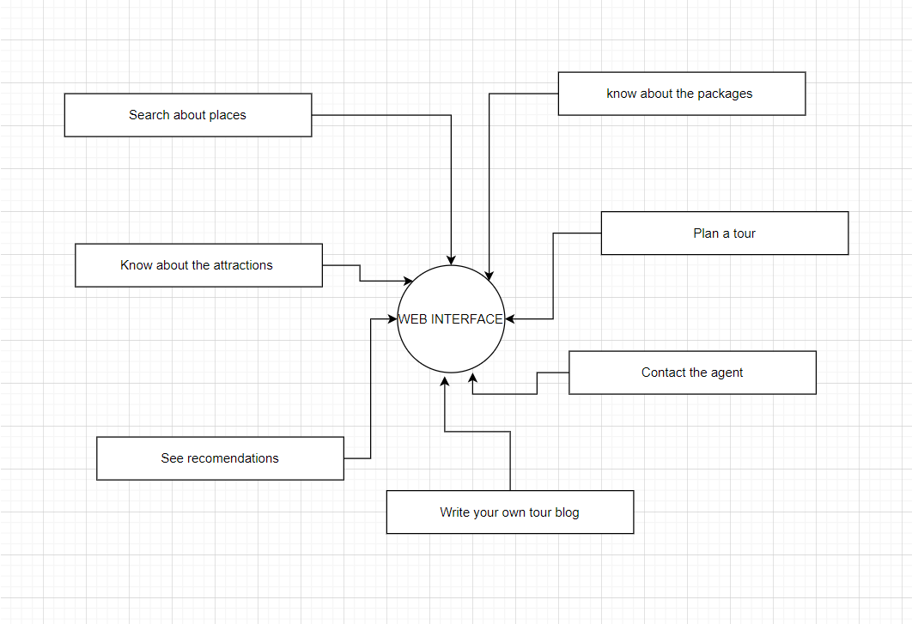

**Users have privilege to do various activities in the web interface**

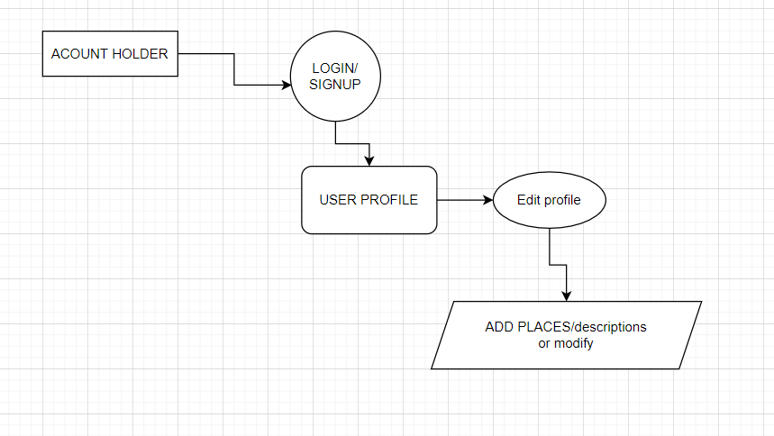

**ADMIN UPLOAD PLACES**

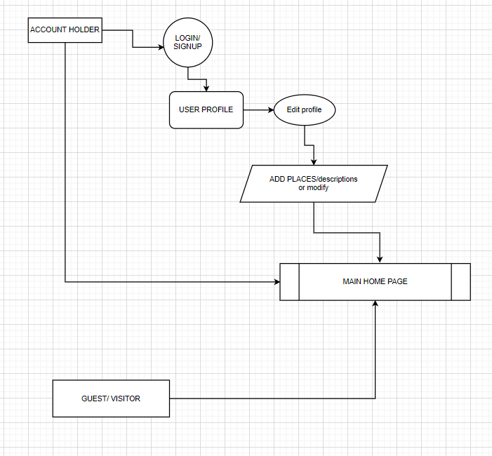

**ANY ACCOUNT HOLDER/ VISITOR CAN ACESS THE HOME PAGE AND CAN SEARCH ABOUT DIFFERENT PLACES**

**REFERENCES**

1. ISSN: 2347-3215 Volume 1 Number 1 (2013) pp. 84-88

[Microsoft Word - 8.doc (d1wqtxts1xzle7.cloudfront.net)](https://d1wqtxts1xzle7.cloudfront.net/51390008/T.Arunmozhi_and_A._Panneerselvam.pdf?1484650020=&response-content-disposition=inline%3B+filename%3DT_Arunmozhi_and_A_Panneerselvam.pdf&Expires=1614666717&Signature=YSZkmJg8JBio3DDAiVuuMRtAh9qP5pxs8ygs72ZJUmMcIwrPDYGKVMLcITrcDg0LnorRtMePZeKrP0UrHXPHRLr-HtI34x14LFIegKR4F8ndQ7U1qwDuUS-7bI0i~U~r2b7t0ePX-O5DE~7GvTIlRiShUWyLrvtXj~OusXdQ98HytgGCnt2fRex8EIfIzanTWUXmou0Oq7IYVbjMAwP8ttiMrNi87bFhnkeBwtIGKLBoMXzhK~stleV9hp-k2wXrC-r5nry9ZjpNvQMYmN3UWU0UvRyFHeg1KLCespWZ5dx7XzSiW8MNRSbMiYpqi3o6PFdP9PuVPdaMtDexdaq~7Q__&Key-Pair-Id=APKAJLOHF5GGSLRBV4ZA)

1. Fang Gao and Liangyu Li 2020 J. Phys.: Conf. Ser. 1533 032092

[pdf (iop.org)](https://iopscience.iop.org/article/10.1088/1742-6596/1533/3/032092/pdf)

[**Tourism Management**](https://www.sciencedirect.com/science/journal/02615177)

[Volume 19, Issue 5](https://www.sciencedirect.com/science/journal/02615177/19/5), October 1998, Pages 409-421

1. [Strategic use of information technologies in the tourism industry - ScienceDirect](https://www.sciencedirect.com/science/article/abs/pii/S0261517798000387?via%3Dihub)

[**Computers in Human Behavior**](https://www.sciencedirect.com/science/journal/07475632)

[Volume 50](https://www.sciencedirect.com/science/journal/07475632/50/supp/C), September 2015, Pages 564-575

1. [Comparing the attributes of online tourism information sources - ScienceDirect](https://www.sciencedirect.com/science/article/abs/pii/S0747563215001843)